Titan Diving Invite Results
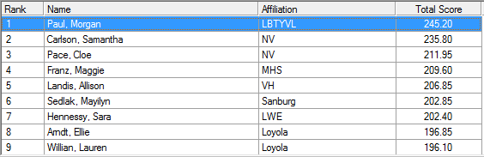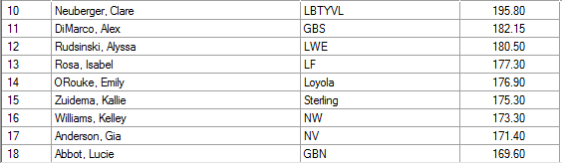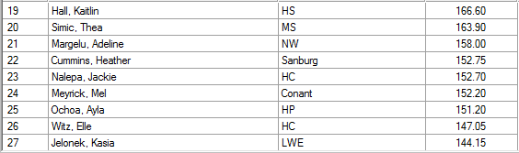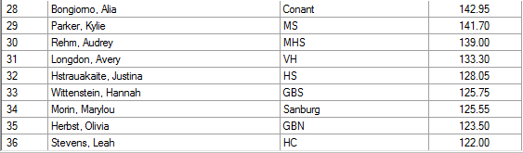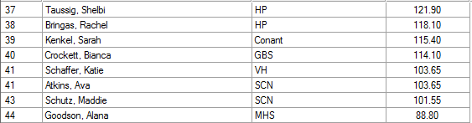

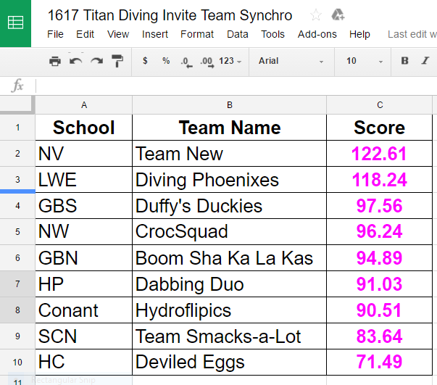
*I sent all coaches who entered a synchro team the link to the excel spread sheet for synchro scores.

